# Project Proposal Plan: EJECT_ME

Key Dates

Week7 - Submit project proposal (2%)

Week9 - Initial Feedback Submission (5%)

Week11 - Short Promotion Video (8%)

Week12 - Final Demo + Video (40% + 25%)

A1-A2 - Final individual code Viva (20%)

Our project scenario:

This project is ideal for people who find it awkward to remove a USBC device from a port due to a specific setup. For those people who choose automation to grab their devices from the ports due to safety or injury.

Planned features for EJECT_ME robot:

* To properly orient and position the end-effector to grab the correct USB C device accordingly from the port and deliver it to the desired pose chosen by the user.
* Have an environment integrated with the simulation.
* Use colour detection or sensor to get desired pose of the USB slot.

Safety Features:

* System reacts to user’s emergency stop action.
* Trajectory reacts to simulated sensor input (e.g light curtains.)
* Trajectory reacts to a forced simulated upcoming collision.
* Make robot retreat from a simulated safety symbol using visual serving and RMRC.

GUI Interface:

* Be able to choose which port the user wants a USBC ejected from.
* Teach command: to set joint configurations like home state q configurations and desired q configurations for the hand over.
* Software E-stop.

Proposed execution of EJECT_ME robot:

Week 8:

1. Create Hans Cute Robot by using DH parameters.
2. Integrate CAD ply files onto the robot.
3. Integrate environment using Ply files.

* Hans Cute robot.
* USBC ports; from either a USBC dock or a monitor/TV with USBC ports.
* End-effector gripper. Scale of the gripper should be considered to fit grabbing the USBC properly.
* Wall, tables etc …

1. Perform animation to desired poses with desired orientation. Such as trajectory **with** **collision avoidance and detection**.
2. Perform animation with colour detection. Use MATLAB toolboxes colour detection to simulate sensor.
3. Integrate GUI into the code.

* Software E-stop.
* Teach command and set joint configurations.
* Choose which port.

1. Work on Initial Feedback stage:

* SWMS and Risk assessment for real robot.
* Regular repository commits for evidence of progress.
* Spark+ report on participation of other team member(s).

Week 9:

1. Integrate Physical E-stop.

* Build a Physical looking E-stop.
* Its use must be integrated as input into the code. Thereby raspberry Pi may be needed.

1. Trajectory reacts to simulated sensor input. (Light curtains in MATLAB.)
2. Trajectory reacts to forced simulated upcoming collision.
3. Make robot retreat from a simulated safety symbol using visual serving and RMRC.

Week 10:

1. Debug and complete the code for the assignment.
2. Optimise the code if needed.
3. Make a short promotional video for Week 11 assignment.
4. Introduce new features if time permits. Such as reverse operation of plugging USBC as oppose to unplugging. ****

Week 11:

1. Continue to optimise the code.
2. Prepare for Demo.
3. Build Video.

Week 12:

1. Prepare for VIVA.

Planned allocation of task:

|  |  |  |
| --- | --- | --- |
| TASK | Rebo | Marvin |
| 1 | * |  |
| 2 |  | * |
| 3 |  | * |
| 4 | * |  |
| 5 | * |  |
| 6 | * |  |
| 7 | * |  |
| 8 |  |  |
| 9 |  |  |
| 10 |  |  |
| 11 |  |  |
| 12 |  |  |
| 13 |  |  |
| 14 |  |  |
| 15 |  |  |
| 16 |  |  |
| 17 |  |  |
| 18 |  |  |
| 19 |  |  |

DOCUMENTS:

D_H PARAMETERS

|  |  |  |  |  |
| --- | --- | --- | --- | --- |
| Link | d | a | alpha | Offset |
| 1 | 0.317 | 0.081 | Pi/2 | -Pi/2 |
| 2 | -0.1925 | 0 | -Pi/2 | -Pi/2 |
| 3 | 0.4 | 0 | -Pi/2 | 0 |
| 4 | -0.1685 | 0 | Pi/2 | 0 |
| 5 | -0.4 | 0 | -Pi/2 | 0 |
| 6 | 0.1363 | 0 | Pi/2 | 0 |
| 7 | 0.13375 | 0 | 0 | 0 |

Code: Need to put to github



L1 = Link('d',0.317,'a',0.081,'alpha',pi/2,'offset',-pi/2,'qlim', [-2*pi,2*pi]);

L2 = Link('d',-0.1925,'a',0,'alpha',-pi/2,'offset',-pi/2,'qlim', [-2*pi,2*pi]);

L3 = Link('d',0.4,'a',0,'alpha',-pi/2,'offset',0,'qlim', [-2*pi,2*pi]);

L4 = Link('d',-0.1685,'a',0,'alpha',pi/2,'offset',0,'qlim', [-2*pi,2*pi]);

L5 = Link('d',0.4,'a',0,'alpha',-pi/2,'offset',0,'qlim', [-2*pi,2*pi]);

L6 = Link('d',0.1363,'a',0,'alpha',pi/2,'offset',0,'qlim', [-2*pi,2*pi]);

L7 = Link('d',0.13375,'a',0,'alpha',0,'offset',0,'qlim', [-2*pi,2*pi]);

r1 = SerialLink([L1 L2 L3, L4 L5 L6 L7], 'name', 'Sawyer');

scale = 0.5;

workspace = [-4 4 -4 4 -4 4];

r1.base = transl(0,0,-0.9);

q = zeros(1,7);

r1.plot(q,'scale',scale);

r1.teach

Link provided by Gavin regarding simulation from camera.

* Camera simulation is based on virtual simulation

<https://github.com/RethinkRobotics/sawyer_simulator>

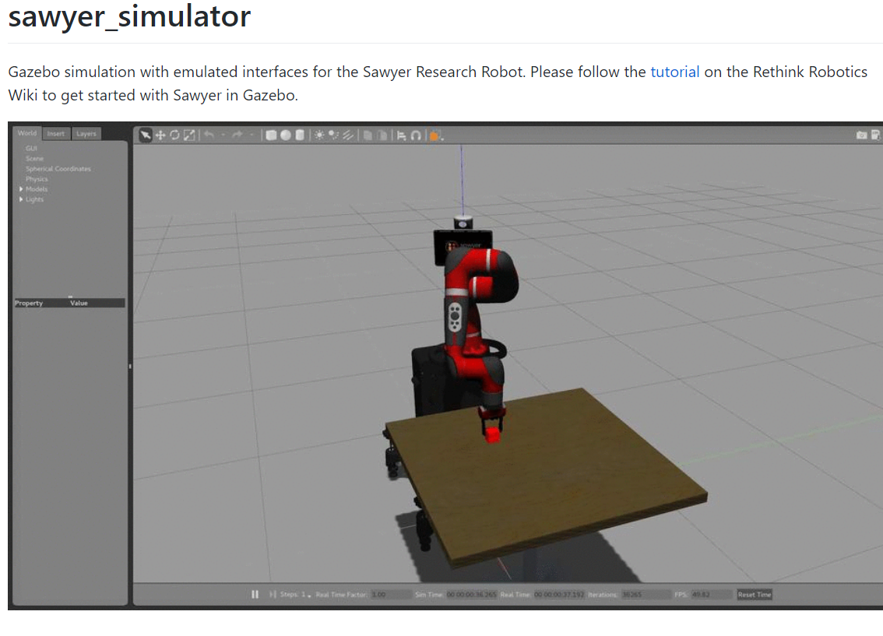

This is the photo Gavin sent imagining the location of the Sawyer robot, there will be flexiility for it to move around and act autonomously on a moving table



My objective is to develop the class for the Sawyer. For this to work unfortunately, the sawyer will require ply files attached to itself, similar to assignment 1

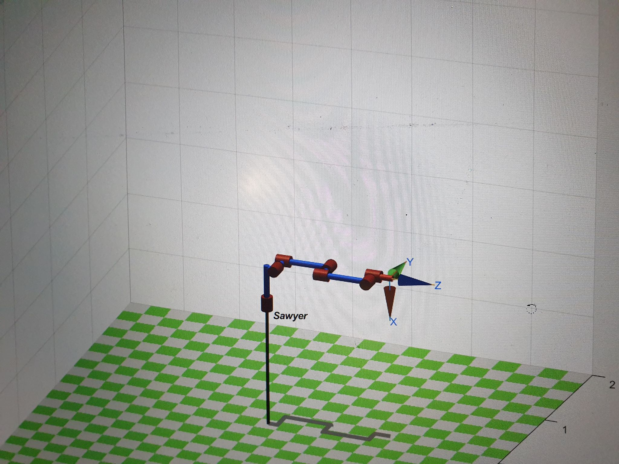

Gavin has responded with a lot of files and details associated with the Sawyer robot. This includes documentation as well. This will take some time to sift through

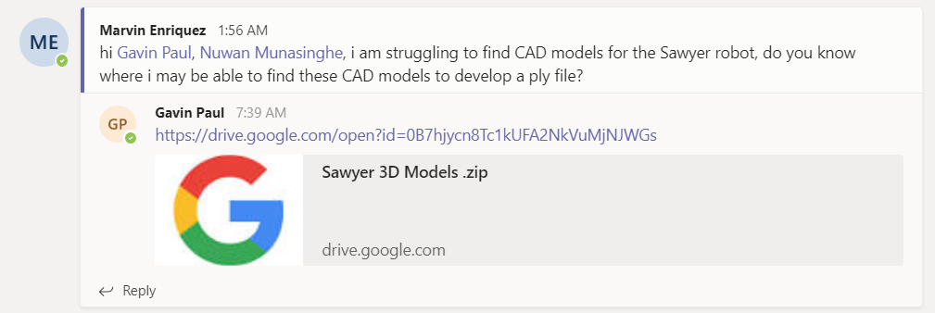

# Objects imported and References (for later use)

Development of ply files in progress. Adjustments will be made based on the DH parameters and the main point of rotation. Previously I got through this is assignment 1 by importing UR10 and replacing the ply files with UR3 files, this will be a little different.

Future adjustments will be made by reimporting the ply files into blender and shifting the origin point

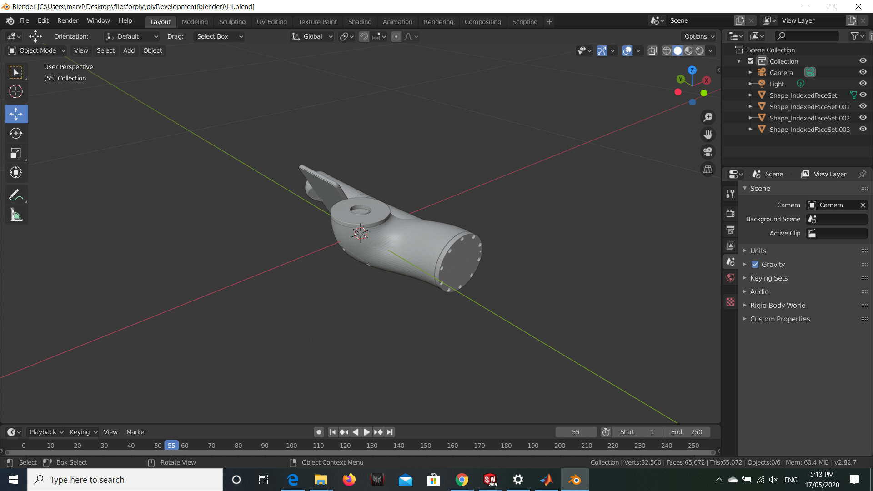

Going to adjust and develop the class folder to detail the Sawyer

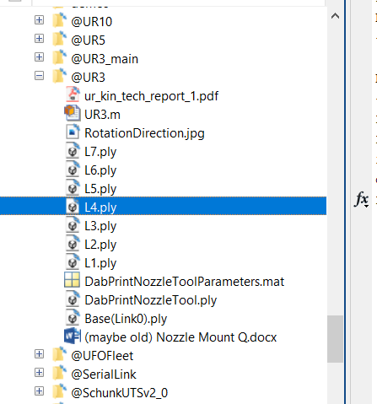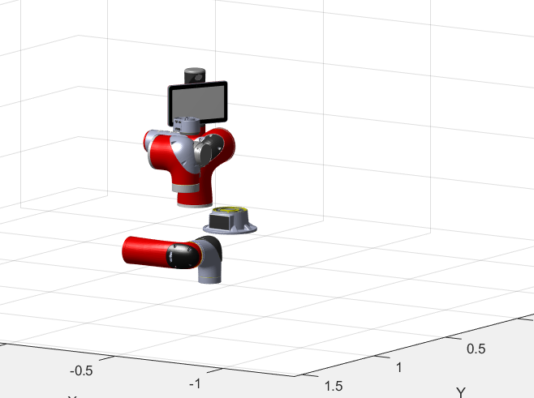

Further development, all files present, will need to appropriately set up position

HDMI Male plug (cord will be enacted as Spleen if possible – in the future)

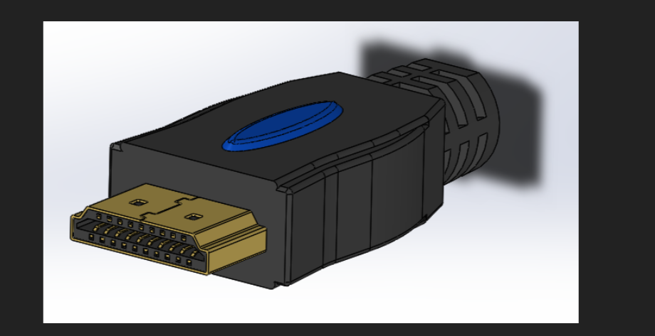

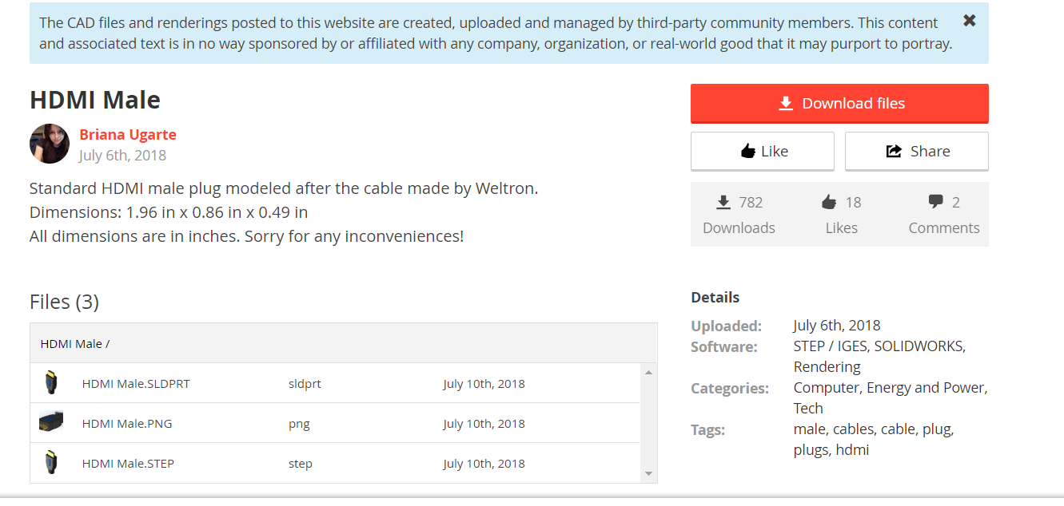

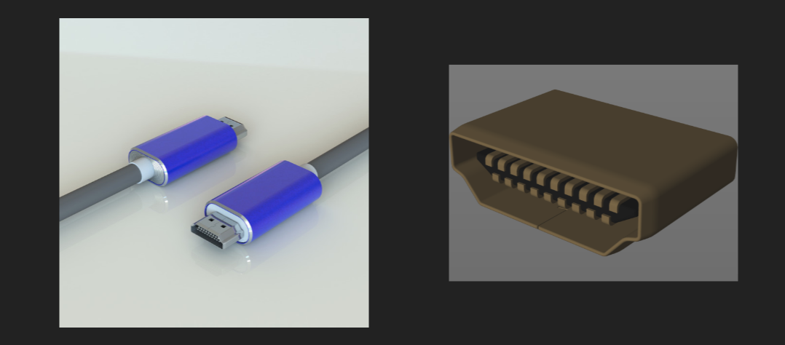

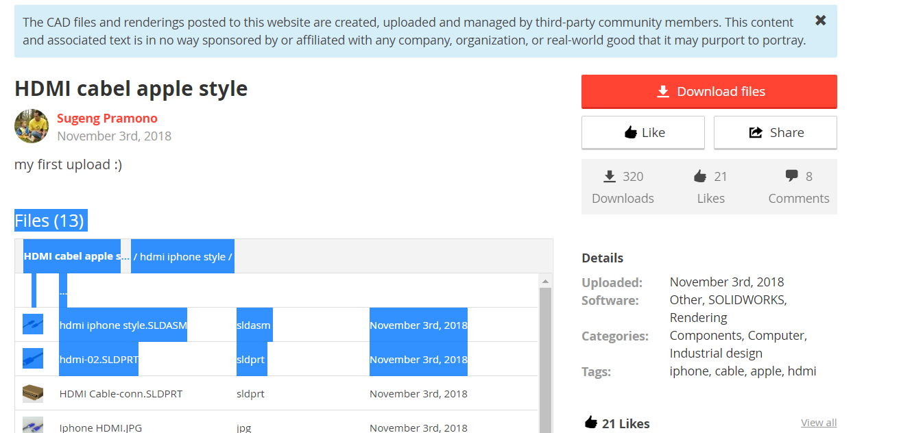

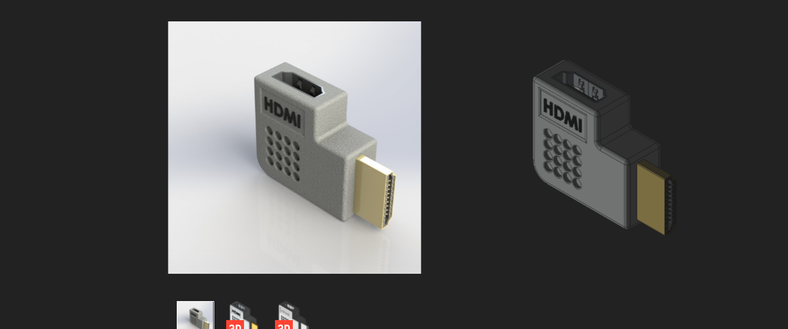

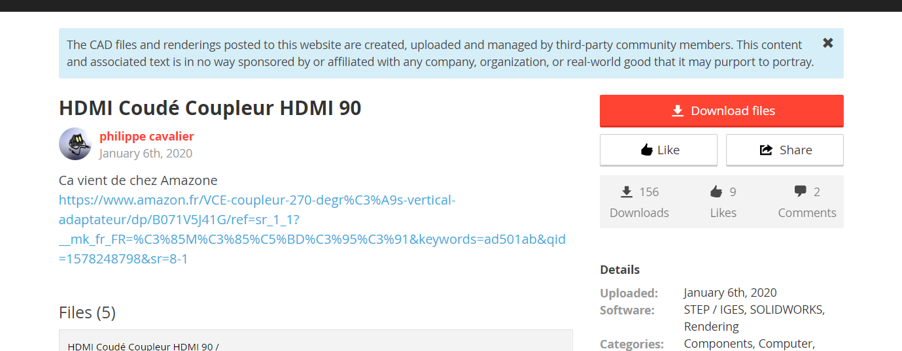

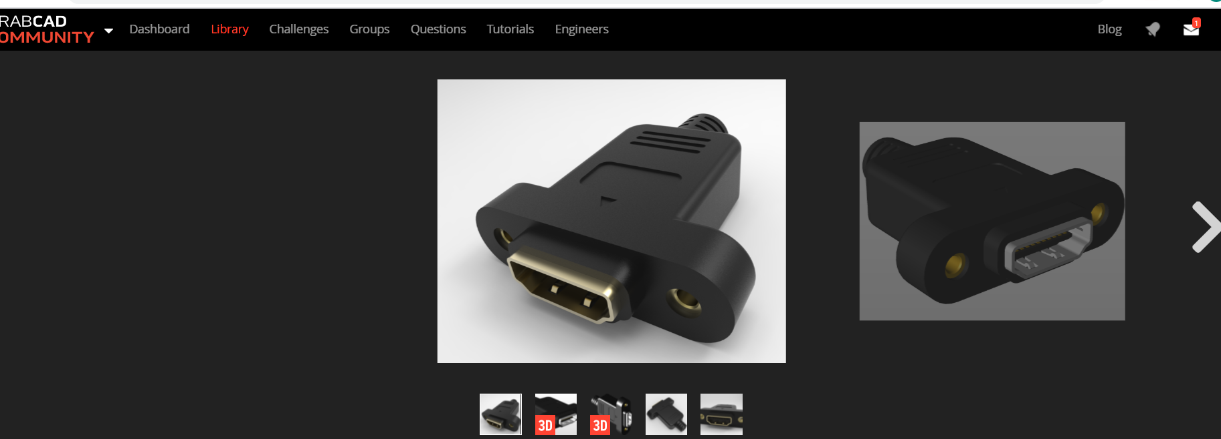

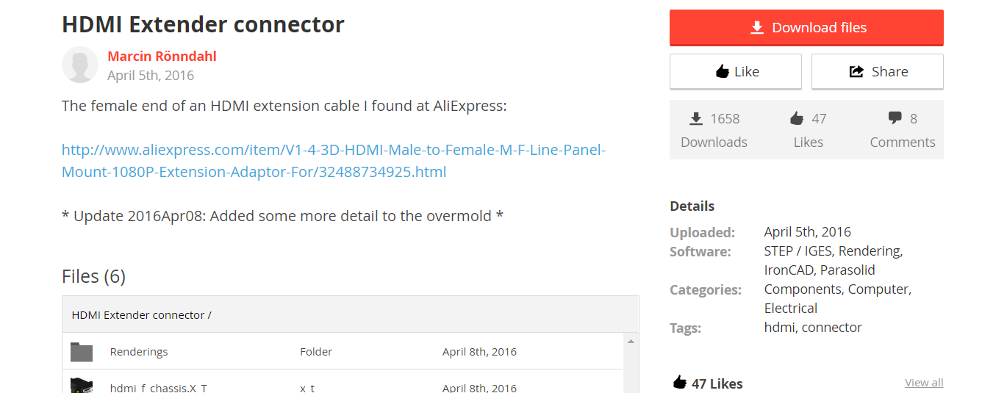

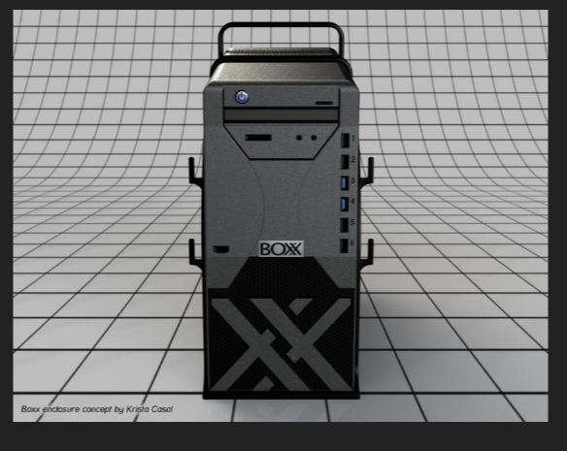

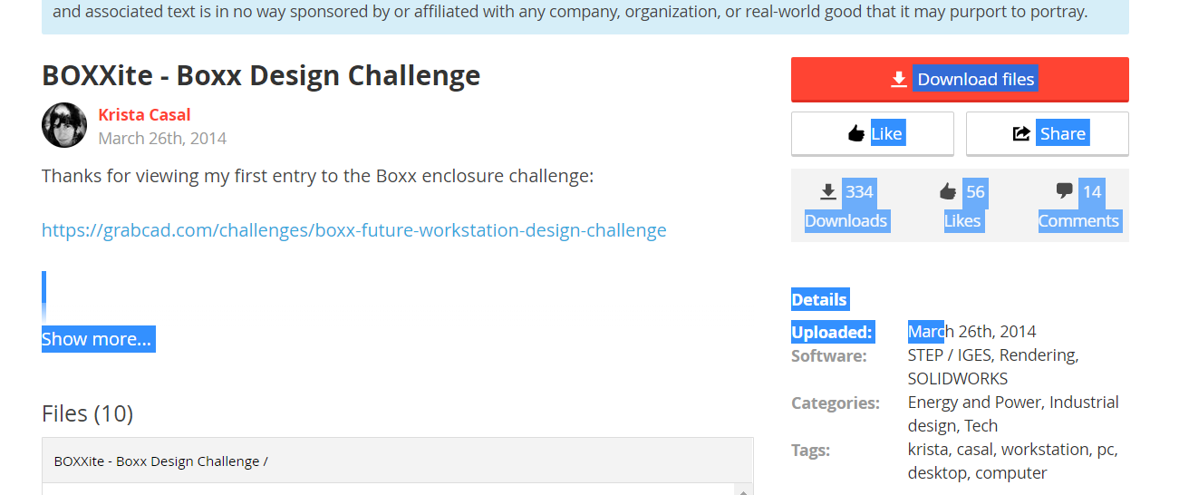

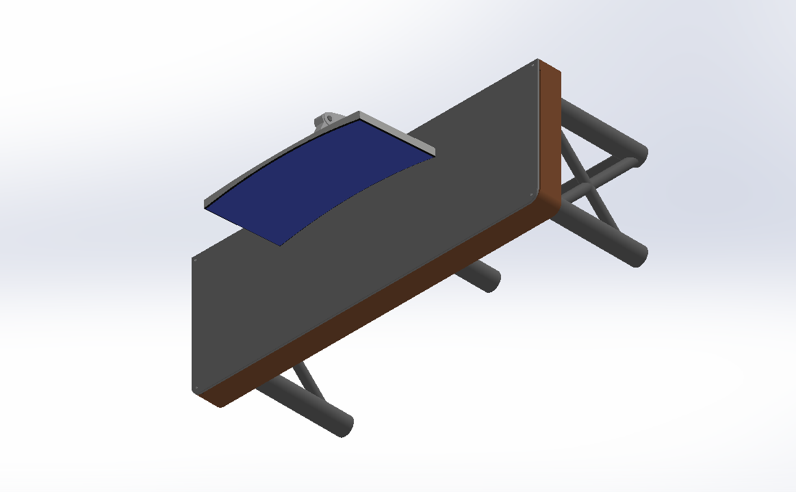

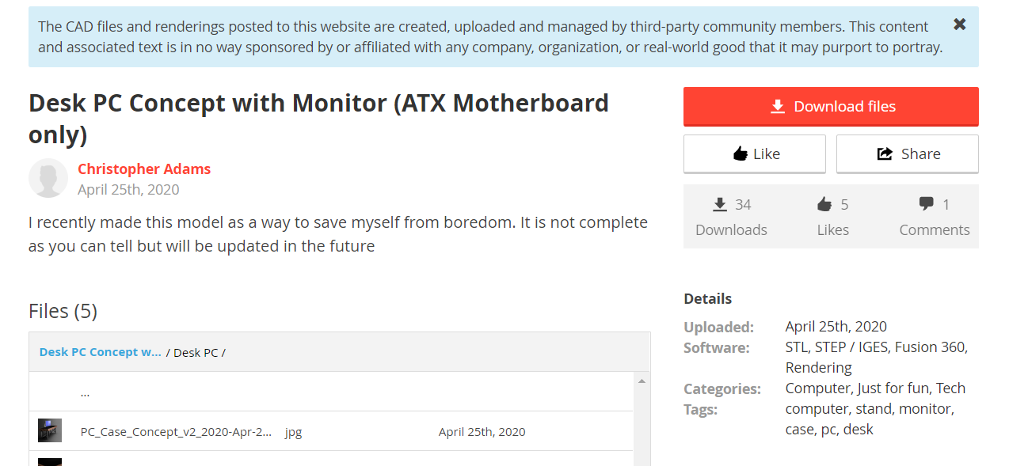

# Safety Featured of Operation Zone

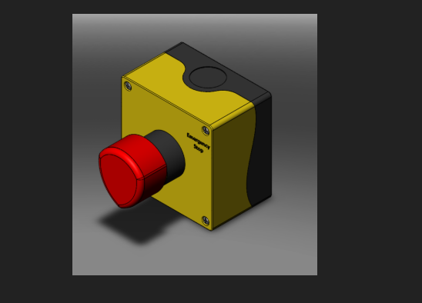

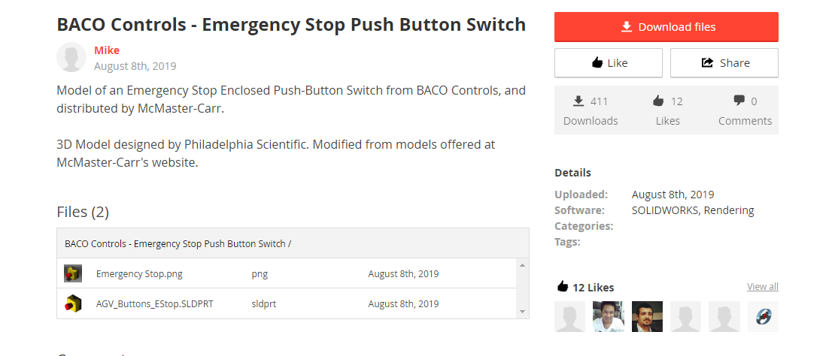

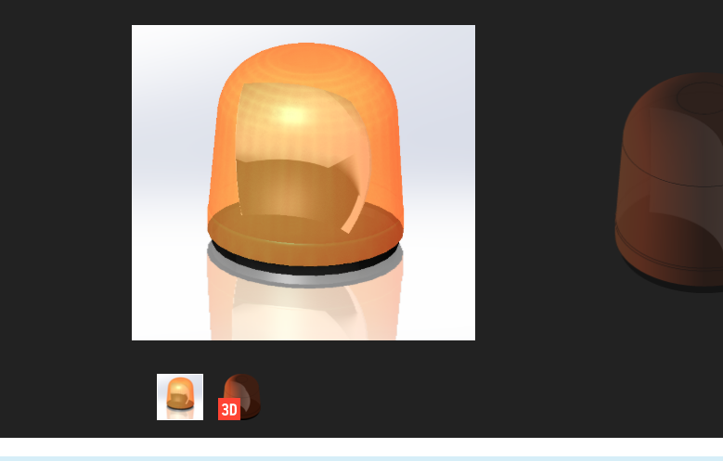

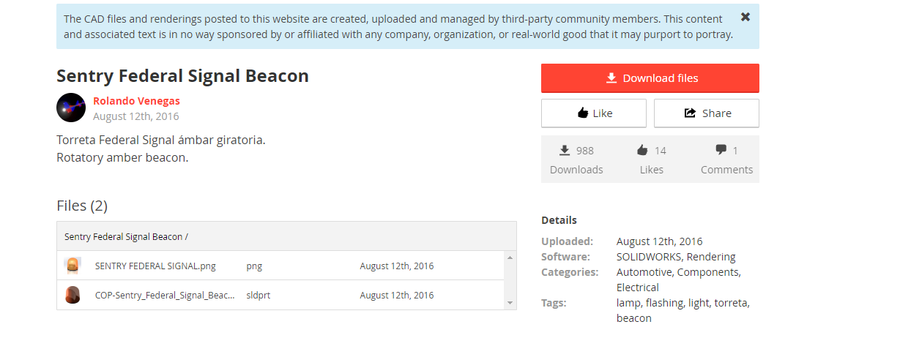

Modelling and Blender orientation for the environment parts

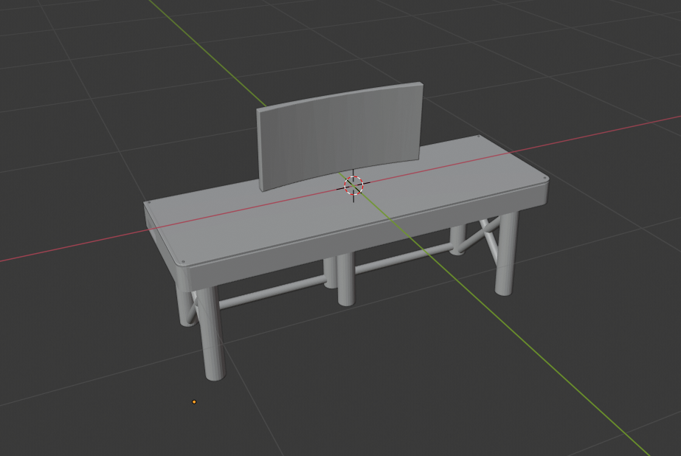

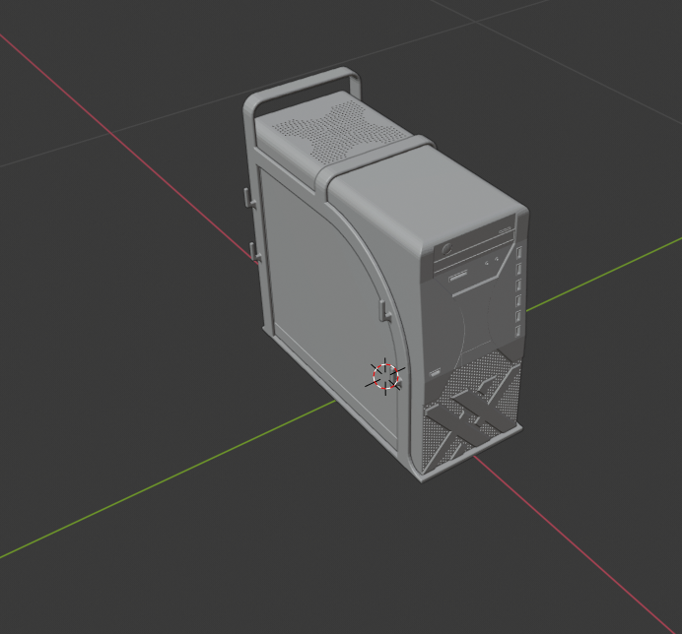

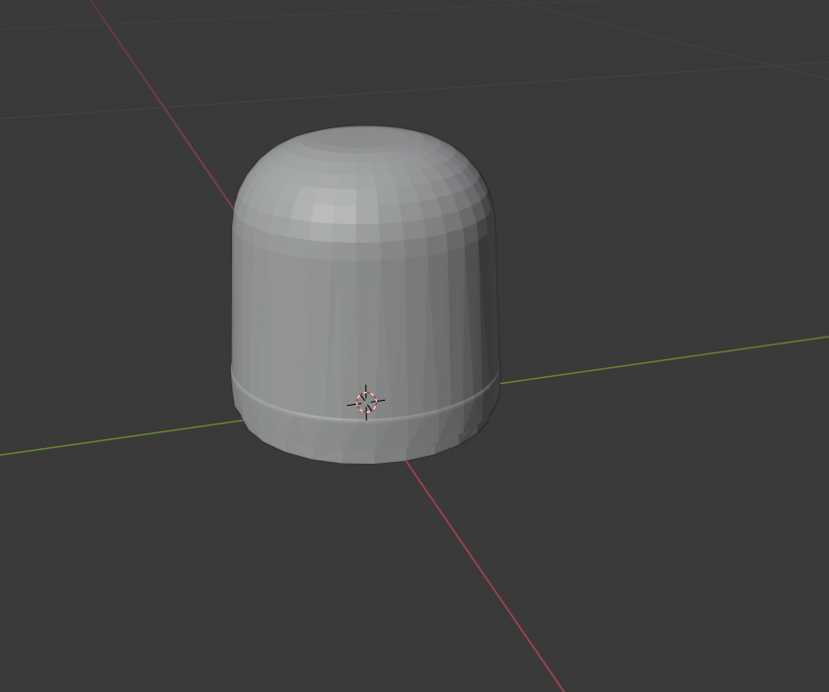

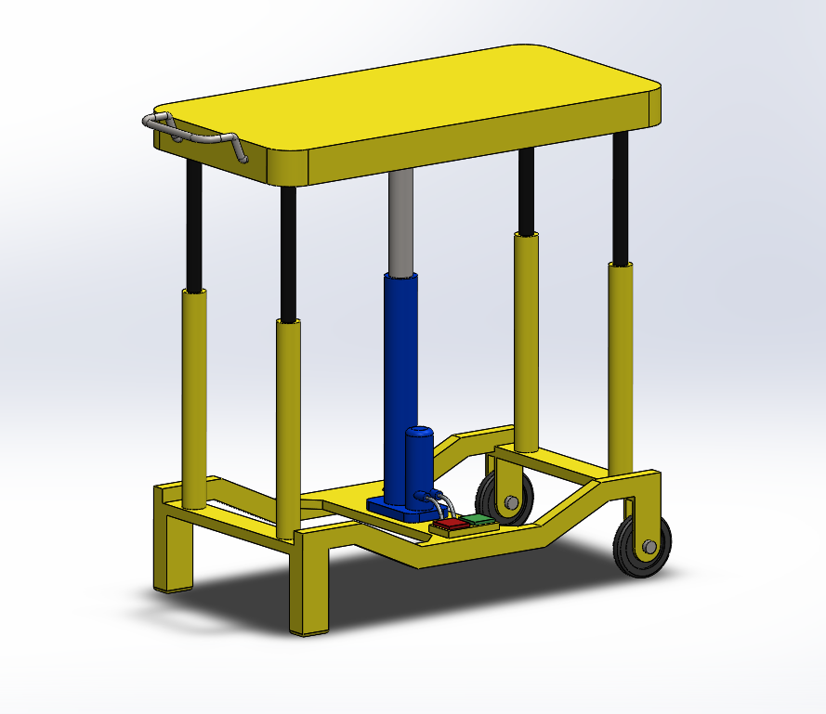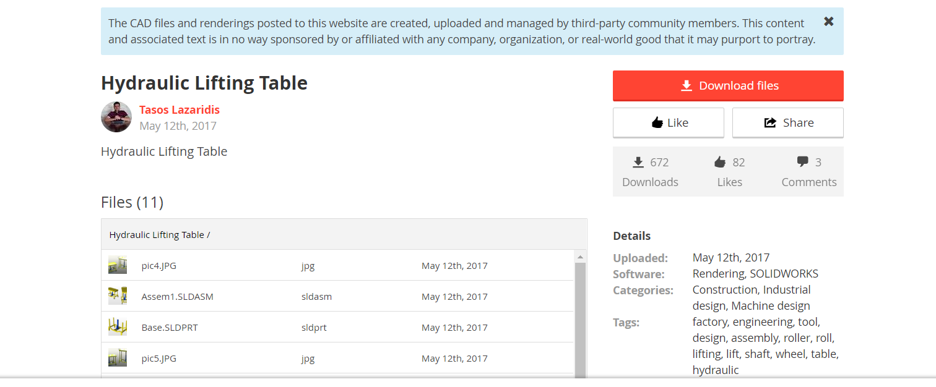

# Workspace Operation Zone

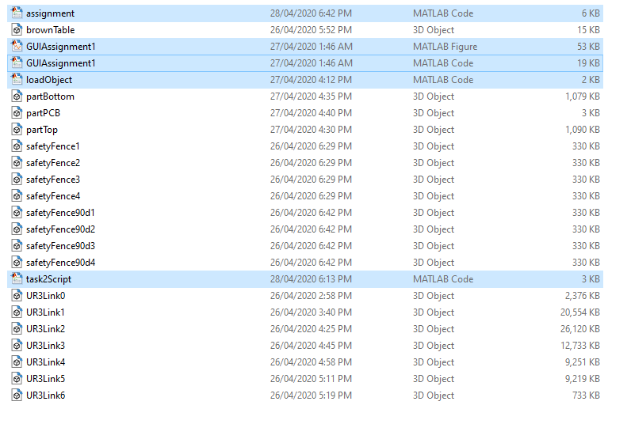

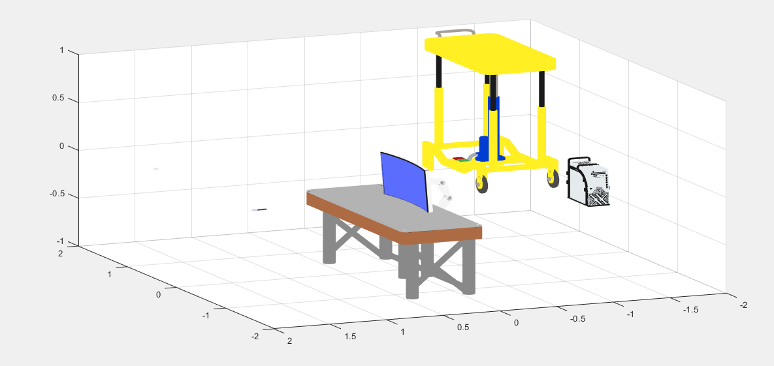

Basic object load function for the environment

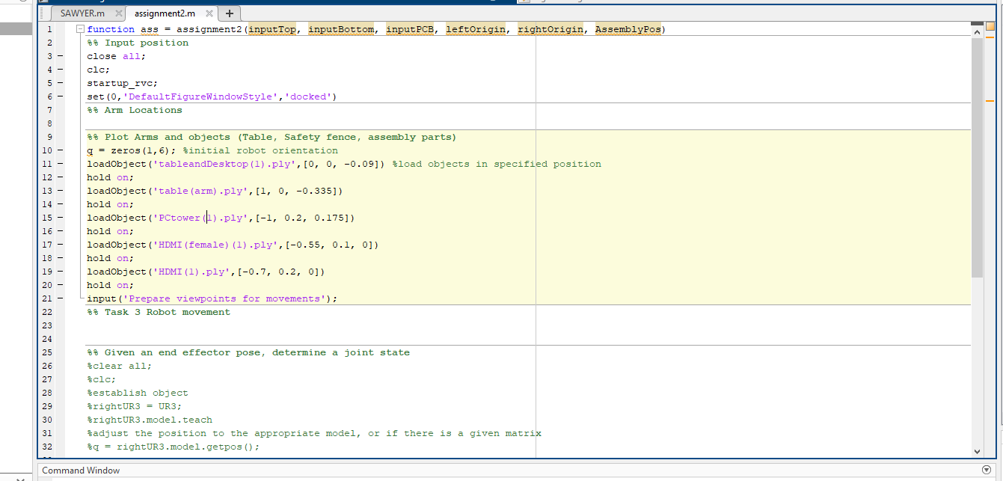

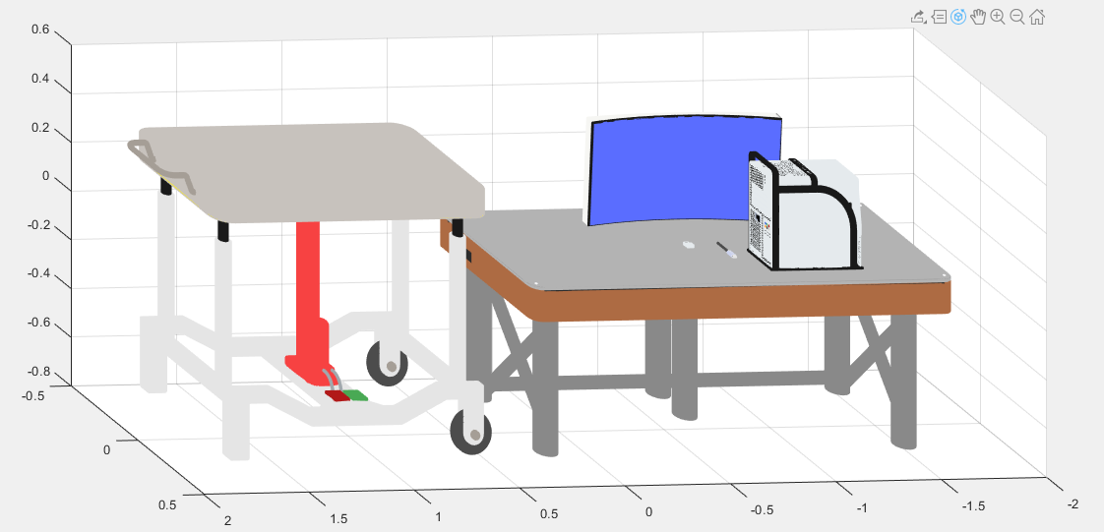

Includes emergency switch and emergency light, will be adjusted later

